**How to use the code:**

1. Download Visual Studio code here if your laptop does not have: <https://code.visualstudio.com/download>

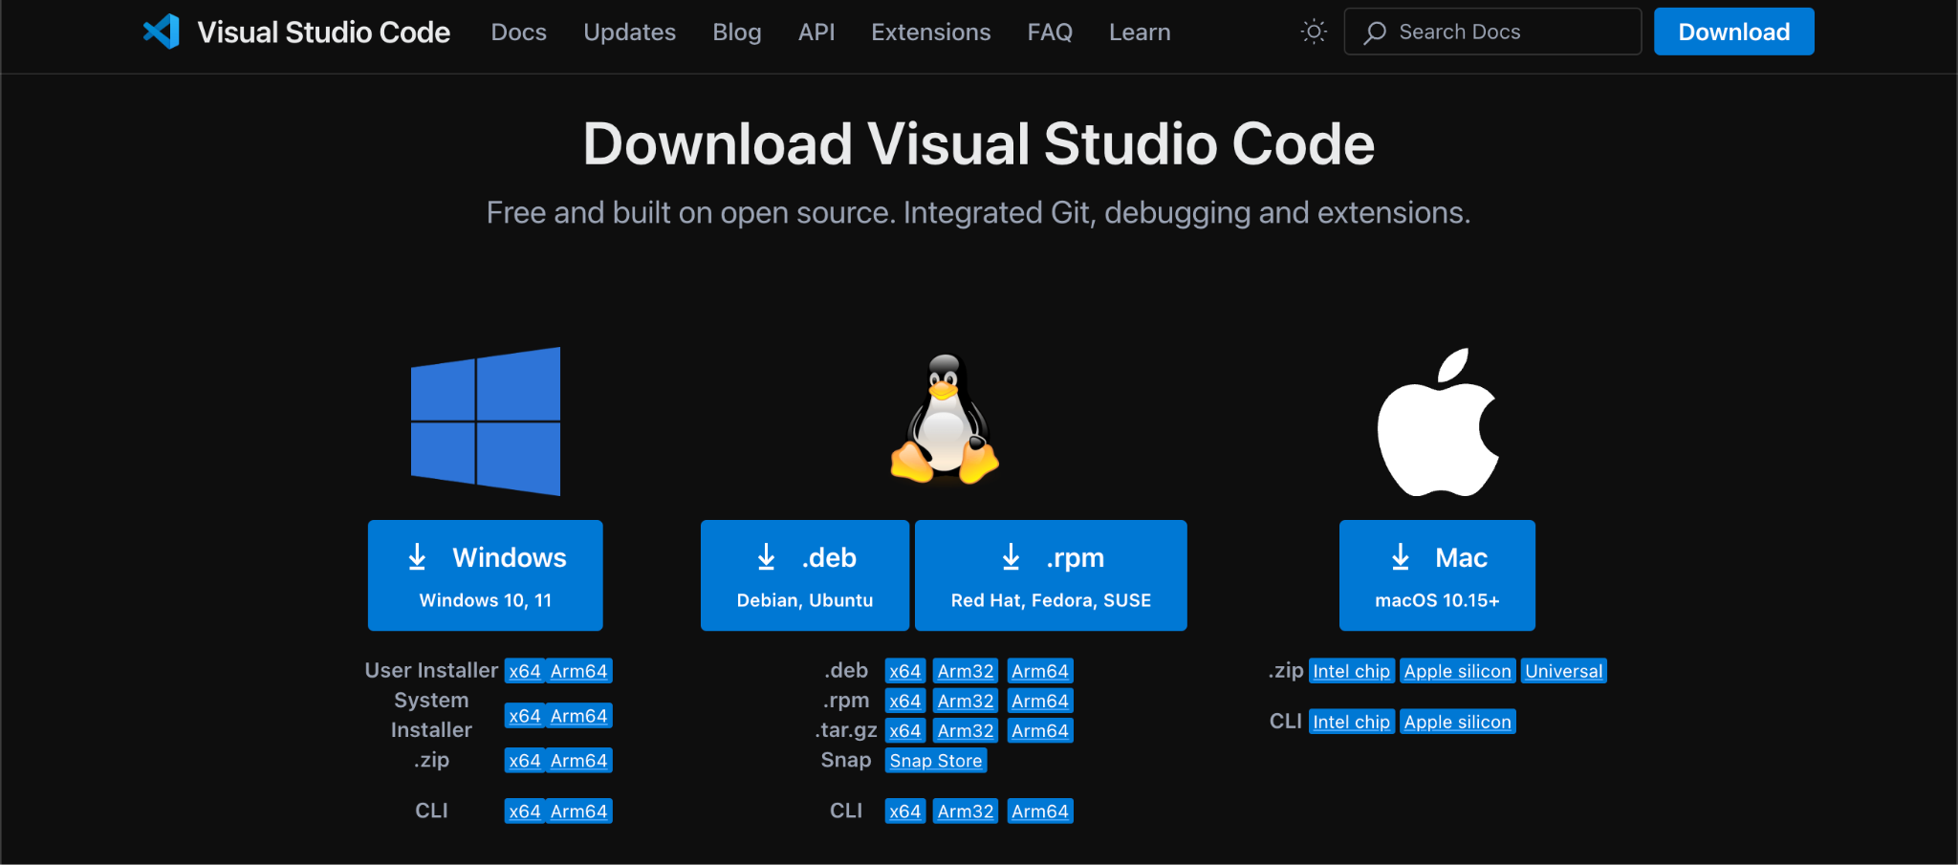

1. Click on the **Maybank2u_SG_Lite_Review_Analysis.ipynb**

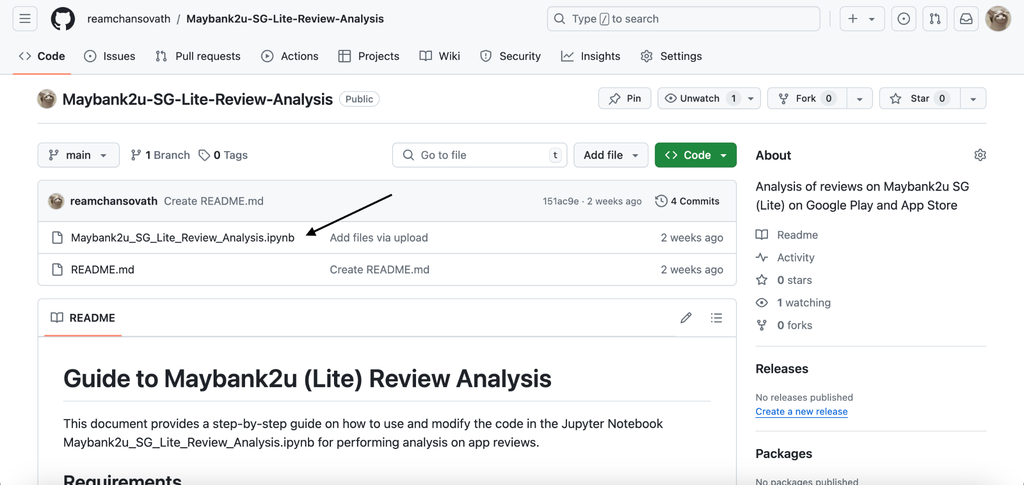

1. Click download

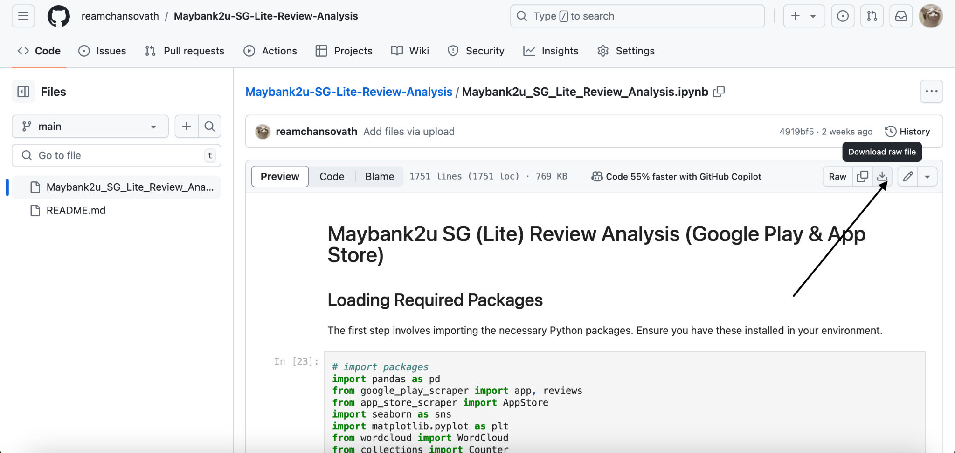

1. Open the file in Visual Studio Code and click Run All:

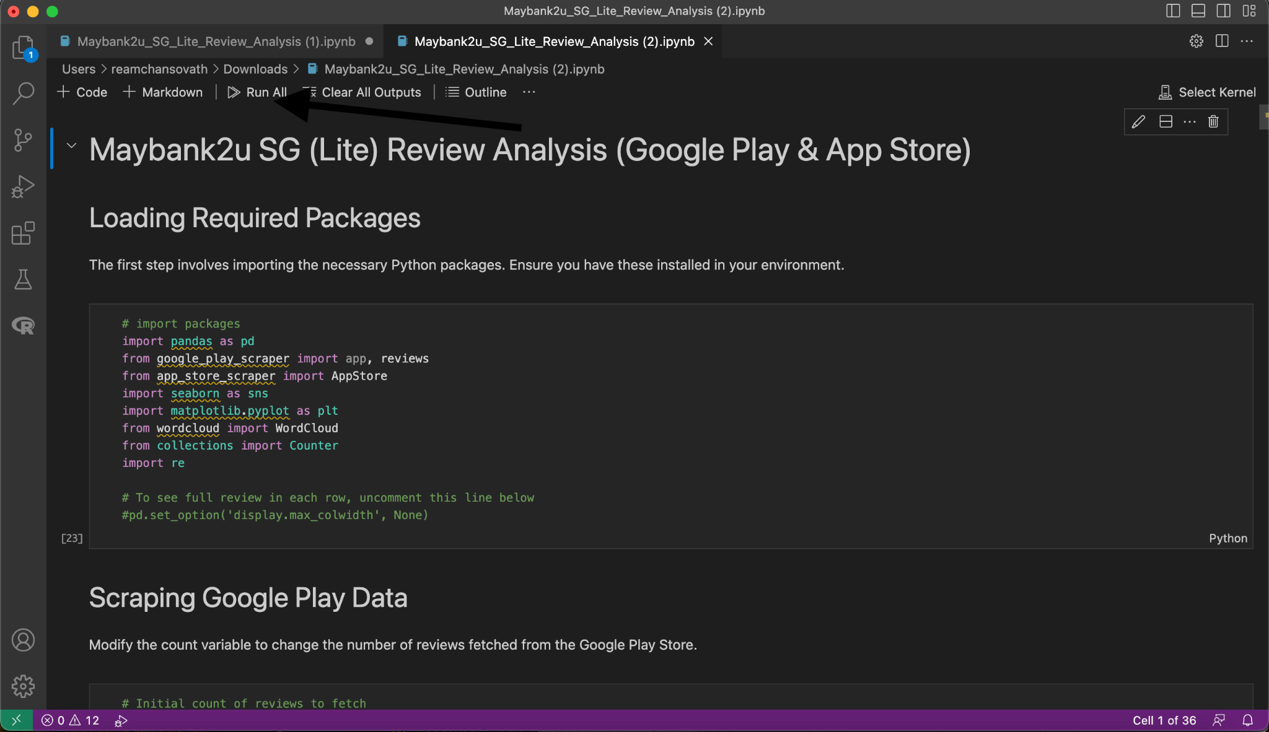

1. You will be able to see:
   1. Bar graph for rating score (2022-2024),
   2. Bar graph for rating score (2024),
   3. Heatmap of Scores by Quarter (Google Play),
   4. Heatmap of Scores by Quarter (App Store),
   5. Heatmap of Scores by App Version (Google Play),
   6. Word Cloud for Reviews with Low Ratings (Google Play),
   7. Frequently Appeared Words (Google Play),
   8. Filter to fetch reviews contain specific word and rating (Google Play)
   9. Word Cloud for Reviews with Low Ratings (App Store),
   10. Frequently Appeared Words (App Store),
   11. Filter to fetch reviews contain specific word and rating (App Store)
2. For **h** and **k**, you can change the word the quotation marks to any other words you want to filter, and/or change the scores to include any scores you want to search.

Eg: "paynow"

Eg: [4,5]

Then you can click on run (dashed arrow)

